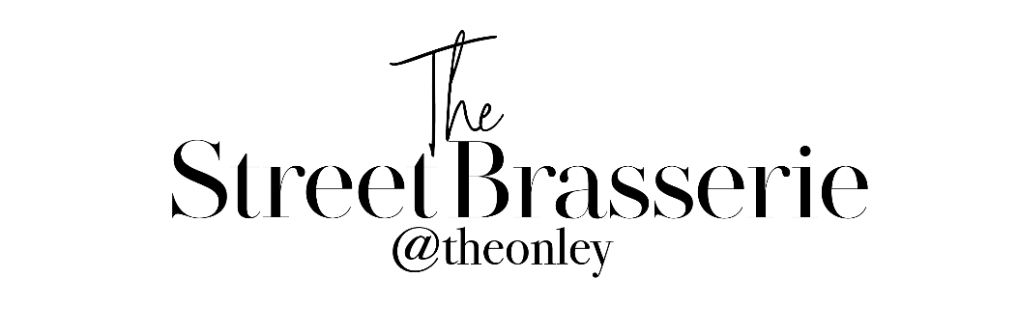

Nibbles
Mixed Olive Bowl £3.00
Mixed Olives, Fresh Ciabatta & Hummus £6.00
Fresh Ciabatta, Olive Oil & Balsamic Vinegar £5.00

Starters

Wild Mushrooms On Toast
White Wine, Cream And Tarragon Sauce, Toasted Ciabatta £8
Prawn & Crayfish Cocktail
Crevettes, House Marie Rose Sauce, Salad Garnish & Granary Bread £9
Salt & Pepper Calamari
Chilli Jam, Pineapple & Chilli Salsa £8
Spicy Chicken Wings
Honey Hot Sauce, Blue Cheese Dip and Chilli & Spring Onion £8.50
Haloumi Fries £7.50
Pesto Mayonnaise & Baby Leaf Salad

Great To Share!

Seafood Slate
Mini Prawn Cocktail, Smoked Mackerel, Crevettes, Smoked Salmon, Salad Garnish, House Tartare & Marie Rose and Breads £18.50
Charcuterie Slate
Local Cured Meats, English Cheeses, Pickles, Apricot & Onion Chutney, Olives, Salad Garnish & Breads £18.50
Fully Loaded Nachos
Mature Cheddar Cheese, Mozzarella, Sour Cream, Salsa & Jalapenos £9.00
Add Beef Chilli £5

Salads

Classic Caesar
Gem Lettuce, Aged Parmesan, Croutes & Anchovies £12
ADD:
Chicken Breast- Smoked Salmon- Battered Halloumi
£4.50

Main Courses

Oak Smoked Ham
Hand Cut Chips & Eggs £14
Whitby Scampi
Hand Cut Chips, Tomato and Caper Salad & House Tartare £14
The Onley Beer Battered Fish & Chips
Hand Cut Chips, Garlic and Shallot Blitzed Peas & House Tartare £16
The Onley Half Size Battered Fish & Chips
And all the trimmings! £10
10oz Ribeye Steak
Hand Cut Chips, Thyme Roasted Tomato, Field Mushroom & Baby Leaf Salad £28
Minute Steak
Skinny Fries, Thyme Roasted Tomato, Field Mushroom & Baby Leaf Salad £16
Sweet Potato & Spinach Madras Curry
Basmati Rice, Lime Pickle, Mango Chutney & Garlic Naan (VE) £14

Burgers
All Of Our Burgers Are Served In A Seeded Brioche Bun With Beef Tomato, Gem Lettuce & Red Onion, With Skin On Fries & Slaw

Brasserie Burger
8oz Beef Patty, Emmental Cheese, Pickles, French’s Mustard & Crispy Onions £15
Caribbean Spiced Chicken Burger
Pineapple And Chilli Salsa & Jerk BBQ Sauce £15
Beer Battered Halloumi Burger
Field Mushroom Pesto Mayonnaise £15
Moving Mountains Burger
Smoked Applewood Cheese & Roasted Garlic Mayonnaise (VE)

Sides £4
Skinny Fries-Hand Cut Chips-House Salad-Onion Rings- Garlic Bread- Haloumi Fries

